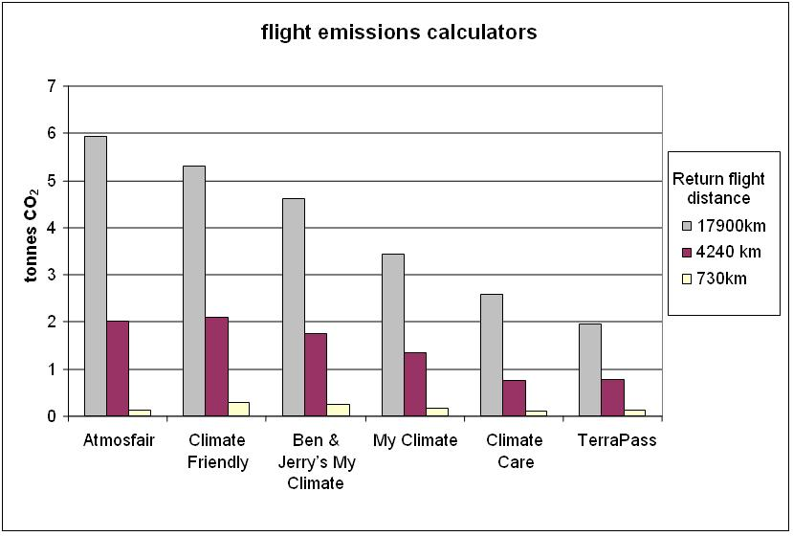
Figure 1 Flight emission calculator results in tonnes CO₂e (as per January 2007).

